Task Nine
语篇形式主要指消息报道，特写文章和新闻评论三种形式。

新闻评论

新闻评论是英文报刊的灵魂，以议论见长，据事说理兼具新闻性和政论性，通常由引论theme论证demonstration和结论conclusion组成，主要分社论editorial述评review和专栏文章column三类。

社论editorial代表报社就某一重大问题发表权威性的言论，往往代表某一党派社团的立场或观点。

Key Learning points:
Try to locate the following sentences in the text materials(page 169-180) and give your understanding about them(注意句子结构成分的分布特征及句意的表达特点)
- That would be a point at which transient fluctuations in oil prices were not jarring, and at which US policy would accept the reality of a permanent shift from $30-a-barrel oil to $130-a-barrel oil.
- Economic recovery alone would soar up much of the excess in the oil market.Another war or revolution in the Gulf----which any prudent person must consider possible----could send the oil-importing nations back into crisis.
- The administration uses this improvement to buttress its case for dissolving the Energy Department.
- The price of oil has been decontrolled, the strategic petroleum reserve is finally being filled, industry is using energy much more efficiently and the gas guzzler is an endangered species.
- But the real issue is how much of what would be economically beneficial is not happening ,and will not happen, under current policies.
- To abandon conservation programs and dismantle research efforts now is to save small amounts of federal dollars at a very large longer-range cost to the economy.
- And hopeful talk about the end of the energy crisis ignores the painful lessons of the past decade.
- They tend to favor incumbents with their campaign contributions , and a result, Mr.Green says, is that it takes a wealthy challenger to make a face of things.

The first article
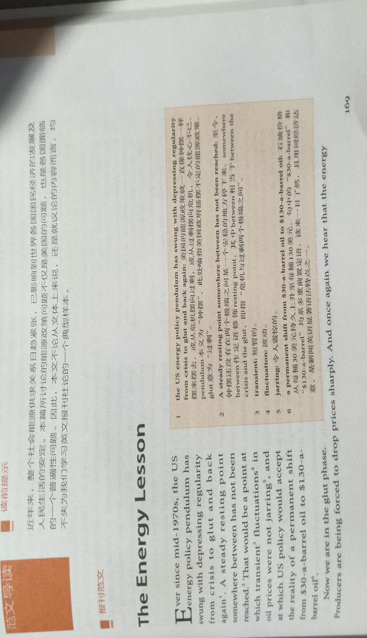

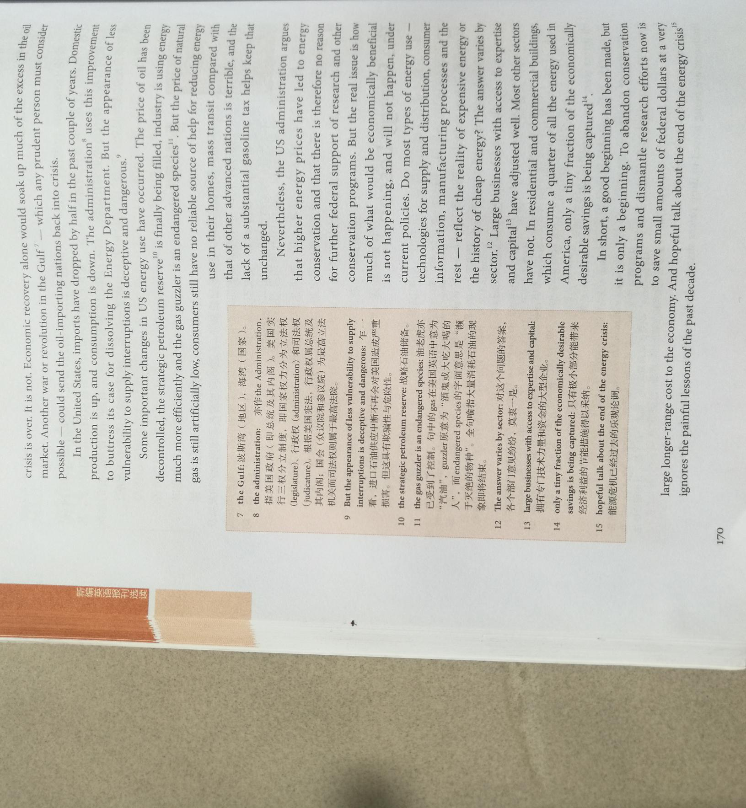

The second article

